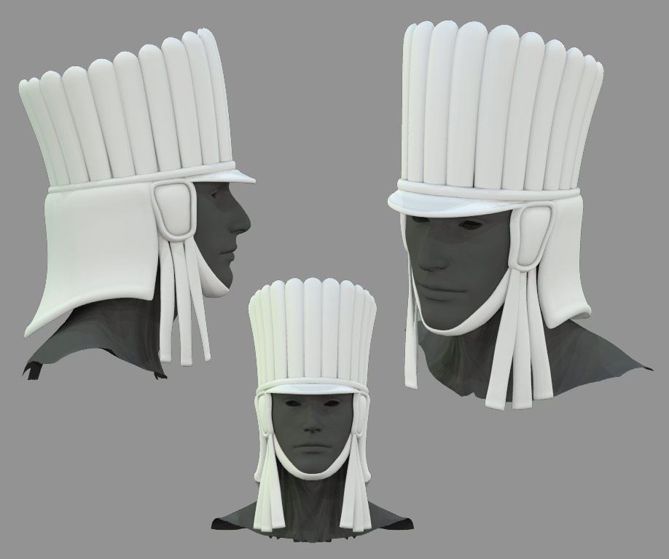

The Yan Koryani

Detailing how the initial Yan Koryani figures will be organized.

(Illustration: The Khil, the distinctive helmet type favoured by the Yan Koryani.)
For our initial Yan Koryani figure release the khil, referred to in the background material as the distinctive style worn by many Yan Koryani troops, seemed to be an appropriate starting point. Information on the Yan Koryani forces comes chiefly from the book “The Armies of Tekumel – Volume II: Yan Kor and Allies”. This thin volume contains illustrations, stats and brief textual descriptions of the various units. Unfortunately, many of the illustrations, and much of the stats and text is contradictory or vague. Information on arms and armour in the Tekumel Sourcebook mentions the khil and discussions with Professor Barker indicated that the Yan Koryani were often less regular in appearance than the Tsolyani.

By making a few assumptions and assigning specific meaning to certain descriptive phrases in the army book descriptions, we were able to sort out a version of what the Yan Koryani units might actually look like. First, we looked for which units might wear the khil and which had their own distinctive headdress. We also took descriptions such as “Full Armour” to mean heavy scale armour unless there was a specific text or illustration indicating otherwise. Similarly, references to “Half Armour” were taken to mean a lighter cuirass armour. By doing this we arrived at a group of units that we could say wore the khil and had certain types of armour.

To take into account the irregularity of the Yan Koryani was another matter. What the Professor had stated was that the armour styles might differ – one man might wear a current style, another might have bits of armour from different sources or a set of antique armour handed down through the family – that sort of thing. As we could not hope to provide too much variation we settled on changing the helmet styles to provide for at least some sort of irregular appearance in the units. We identified what appeared to be three variants of the basic khil: a crested version; a similar helmet, but with a feathered plume; and a second plumed helm with a lower brim.

The following units – the Yan Koryani call them Gureks – were identified as probably wearing the khil:

The Gurek of Tleku Miriya I
The Gurek of Tleku Miriya II
The Gurek of the Valiant of Ke'er
The Gurek of the Turquoise Eye
The Gurek of Niktambo of Rulla
The Gurek of Defense Against Evil
The Gurek of the Clan of the Silver Worm
The Gurek of the Clan of the Black Bough
The Gurek of Makhis
The Gurek of Hekekka Nna
The Gurek of Inimitable Forces of Ancient Kai

The latter unit being from one of Yan Kor’s allied states: Pijena.

Whereas the Tsolyani organize their forces into legions of a specific size and type, such as heavy or medium infantry or Crossbowmen, the Yan Koryani use much larger formations known as Gureks. This is partly because the Yan Koryani forces are raised by individual cities or powerful clans – it is only the influence of the Baron Ald that has molded them into a cohesive force. Each Gurek contains a variety of troop types, of varying strengths, depending upon the city or clan that raised it.

To accommodate the various troop types, we identified the basic weapons and armour that they wore and categorized them depending on fighting style or method. The categories we identified are:

1) 1-Handed Thrusting – Heavy Infantry (ie. spear and shield);
2) 1-Handed Thrusting – Medium Infantry;
3) 2-Handed Thrusting – Heavy Infantry (ie. pikes or halberds);
4) 2-Handed Thrusting – Medium Infantry;
5) 1-Handed Cutting – Medium Infantry (ie. hand weapons, or throwing spears, and shield);
6) 2-Handed Cutting – Medium Infantry (ie. 2-handed swords or flails);
7) Heavy Infantry Archers;
8) Medium Infantry Archers;
9) Crossbowmen.

For each fighting style, two male figure poses and a single female figure pose were made. This provided 27 different base figures. For each of these, the three head variants were applied giving a total of 81 figures. Note that the command figures were done as separate figures.

The intent is to provide the figures comprising each specific Gurek and distinguish the units by the specific weapons used, shield designs and unique Standards borne. The figures made thus far will provide for most of the units listed above. The last three will require additional unique figures and/or special head-swaps to finish them off.

Alan has made the specific weapons, shields and standards for three Gureks: Tleku Miriya I, the Valiant of Ke'er and the Turquoise Eye.

The Gurek of Tleku Miriya I (TM1)

Background Description: To follow

Strength:
5000 x Heavy infantry with long spears, swords and shields;
3000 x Medium infantry with throwing spears, swords and shields;
2500 x Crossbowmen with medium crossbows, swords and large pavise shields;
1000 x Artillerymen who serve 125 onagers.

Composition: Uses Standard: “r”

TM1 Heavy Infantry:
Males: D1, D2, D3, plus three other male figures (missing: Alan is sending these on);
Females: B4, B5, B6.
Notes:
1) All non-crested helmets use the Helmet Plume “i”;
2) All use wire spears to be provided by the customer;
3) All use sword “k”;
4) All use shield “d”.

TM1 Medium Infantry:
Males: Cutting: B1, B2, B3, F1, F2, F3 or Thrusting: C4, C5, C6, D4, D5, D6 or Mix;
Females: Cutting: G1, G2, G3 or Thrusting: A4, A5, A6 or Mix.
Notes:
1) All non-crested helmets use the Helmet Plume “i”;
2) All use wire spears to be provided by the customer;
3) All use sword “k”;
4) All use shield “d”.

TM1 Crossbow Infantry:
Males: A4, A5, A6, C1, C2, C3;
Females: E1, E2, E3.
Notes:
1) All non-crested helmets use the Helmet Plume “i”;
2) All use crossbow “m”;
3) All use sword “j”;
4) Use Pavise shield. (Not shown.)

Artillery: ignore for the present.
The Gurek of Tleku Miriya II (TM2)

Background Description: To follow

Strength:
5000 x Medium infantry with pikes, shortswords and shields;
4000 x Crossbowmen with medium crossbows, swords and large pavise shields;
12000 x Light infantry with slings and bows.

Composition: Uses Standard: “r”

TM2 Medium Infantry:
Males: E4, E5, E6, H4, H5, H6;
Females: A1, A2, A3.
Notes:
1) All non-crested helmets use the Helmet Plume “i”;
2) All use wire pikes to be provided by the customer;
3) All use sword “k”;
4) The shield is not yet ready for this unit (Alan is sending this on).

TM2 Crossbow Infantry: See TM1 Crossbow Infantry

Notes:
1) These are the same figures as those used in Tleku Miriya I.

Light Infantry: ignore for the present.
The Gurek of the Valiant of Ke’er (VoK)

Background Description: To follow

Strength:
2000 x Heavy infantry with long spears, swords and shields;
6000 x Medium infantry with morning stars, swords and shields;
3000 x Archers with longbows.

Composition: Uses Standard: “t”

VoK Heavy Infantry:
Males: Same as TM1 Heavy Infantry
Females: Same as TM1 Heavy Infantry
Notes:
1) These are the same figures as those used in Tleku Miriya I, but with a different shield design;
2) All use wire spears to be provided by the customer;
3) All use sword “k”;
4) All use shield “f”.

VoK Medium Infantry:
Males: Same as TM1 Medium Infantry
Females: Same as TM1 Medium Infantry
Notes:
1) These are the same figures as those used in Tleku Miriya I, but with a different shield design and weapons;
2) All use morning star “l” and sword “j”;
3) All use shield “f”.

VoK Archers:
Males: E1, E2, E3, plus three other male figures (missing: Alan is sending these on);
Females: D1, D2, D3.
Notes:
1) All non-crested helmets use the Helmet Plume “i”;
2) All use bow “o”;
3) All use sword “j”;

The Gurek of the Turquoise Eye (TE)

Background Description: To follow

Strength:
4000 x Heavy infantry with long spears, swords and shields;
4000 x Medium infantry with long barbed spears, swords or axes and shields;
2000 x Archers with composite bows;
2000 x Sappers.

Composition: Uses Standard: “s”

TE Heavy Infantry:
Males: Same as TM1 Heavy Infantry
Females: Same as TM1 Heavy Infantry
Notes:
1) These are the same figures as those used in Tleku Miriya I, but with a different shield design;
2) All use wire spears to be provided by the customer;
3) All use sword “k”;
4) All use shield “e”.

TE Medium Infantry:
Males: Same as TM1 Medium Infantry
Females: Same as TM1 Medium Infantry
Notes:
1) These are the same figures as those used in Tleku Miriya I, but with a different shield design and weapons;
2) All use wire spears to be provided by the customer;
3) All use sword “k” or “j” or axe “n”;
4) All use shield “e”.

TE Archers:
Males: Same as VoK Archers
Females: Same as VoK Archers
Notes:
1) These are the same figures as those used in Valiant of Ke’er;
2) All use bow “p”;
3) All use sword “j”;

Sappers: ignore for the present.
The Following Gureks require additional Shields and Standards to be made…
The Gurek of Niktambo of Rulla (NoR)

Background Description: To follow

Strength:
3000 x Heavy infantry with long spears, swords and shields, also bows;
2000 x Medium infantry with long spears, axes or swords and shields, also bows;
1000 x Artillerymen who serve 500 small ballista.

Composition:

NoR Heavy Infantry:
Males: Same as TM1 Heavy Infantry
Females: Same as TM1 Heavy Infantry
Notes:
1) These are the same figures as those used in Tleku Miriya I, but with a different shield design;
2) All use wire spears to be provided by the customer;
3) All use sword “k”;
4) The shield is not yet ready for this unit.
NoR Heavy Archers:
Males: A1, A2, A3, H1, H2, H3;
Females: F1, F2, F3.
Notes:
1) All non-crested helmets use the Helmet Plume “i”;
2) All use bow “p”;
3) All use sword “j”;

NoR Medium Infantry:
Males: Same as TM1 Medium Infantry
Females: Same as TM1 Medium Infantry
Notes:
1) These are the same figures as those used in Tleku Miriya I, but with a different shield design and weapons;
2) All use wire spears to be provided by the customer;
3) All use sword “k” or “j” or axe “n”;
4) The shield is not yet ready for this unit.
NoR Medium Archers:
Males: Same as VoK Archers
Females: Same as VoK Archers
Notes:
1) These are the same figures as those used in Valiant of Ke’er;
2) All use bow “p”;
3) All use sword “j”;

Artillery: ignore for the present.
The Gurek of Defense Against Evil (DAE)

Background Description: To follow

Strength:
4000 x Heavy infantry with halberds, swords or swords and shields;
4000 x Medium infantry with long spears, swords and shields;
2000 x Light infantry with slings, clubs and small shields.

Composition:

DAE Heavy Infantry Halberdiers:
Males: B4, B5, B6, G4, G5, G6;
Females: B1, B2, B3.
Notes:
1) All non-crested helmets use the Helmet Plume “i”;
2) All use halberds – not yet made;
3) All use sword “k”;

DAE Heavy Infantry w. Sword and Shield:
Males: Same as TM1 Heavy Infantry
Females: Same as TM1 Heavy Infantry
Notes:
1) These are the same figures as those used in Tleku Miriya I, but with a different shield design and weapons;
2) All use sword “k”;
3) The shield is not yet ready for this unit.

DAE Medium Infantry:
Males: Using Thrusting figures from TM1
Females: Using Thrusting figures from TM1
Notes:
1) These are the same figures as those used in Tleku Miriya I, but with a different shield design and weapons;
2) All use wire spears to be provided by the customer;
3) All use sword “k”or “j”;
4) The shield is not yet ready for this unit.

Light Infantry: ignore for the present.
The Gurek of the Clan of the Silver Worm (CoSW)

Background Description: To follow

Strength:
4000 x Heavy infantry with pikes, swords and small shields;
3000 x Medium infantry with 2-handed flails, swords and small shields;
5000 x Light infantry with slings;
1000 x Sappers with shortswords.

Composition:

CoSW Heavy Infantry:
Males: Same as DAE Heavy Infantry Halberdiers
Females: Same as DAE Heavy Infantry Halberdiers
Notes:
1) These are the same figures as those used in Defense Against Evil but with different weapons and shield;
2) All use wire pikes to be provided by the customer;
3) All use sword “k”;
4) The shield is not yet ready for this unit.

CoSW Medium Infantry:
Males: G1, G2, G3, F4, F5, F6;
Females: C1, C2, C3.
Notes:
1) All non-crested helmets use the Helmet Plume “i”;
2) All use 2H-Flails – not yet made;
3) All use sword “j”;

Sappers and Light Infantry: ignore for the present.
The Gurek of the Clan of the Black Bough (CoBB)

Background Description: To follow

Strength:
3000 x Heavy infantry with long spears, scimitars or axes and small shields;
2000 x Medium infantry with 2-handed sword;
5000 x Light infantry with slings.

Composition:

CoBB Heavy Infantry:
Males: Same as DAE Heavy Infantry Halberdiers
Females: Same as DAE Heavy Infantry Halberdiers
Notes:
1) These are the same figures as those used in Defense Against Evil but with different weapons and shield;
2) All use long spears – not yet made;
3) All use sword “k”;
4) The shield is not yet ready for this unit.

CoBB Medium Infantry:
Males: Same as CoSW Medium Infantry
Females: Same as CoSW Medium Infantry
Notes:
1) These are the same figures as those used in the Clan of the Silver Worm but with different weapons;
2) All use 2H-Swords – not yet made;
3) All use sword “j”;

Light Infantry: ignore for the present.
The Following Gureks require Additional Figures to be made…
The Gurek of Makhis (Mk)

Background Description: To follow

Strength:
5000 x Medium infantry with long barbed spears, axes or swords and small shields;
7000 x Light infantry with longbows, swords and small shields.

Composition:

Mk Medium Infantry:
Males: Using pike figures from TM2
Females: Using pike figures from TM2
Notes:
1) These are the same figures as those used in Tleku Miriya 2, but with a different shield design and weapons;
2) All use long spears – not yet made;
3) All use sword “j”or axe “n”;
4) The shield is not yet ready for this unit.

Mk Light Infantry Longbowmen:
Males: Requires Additional Figures
Females: Requires Additional Figures
Notes:
1) The longbowmen still have to be made.

The Gurek of Hekekka Nna (HKN)

Background Description: To follow

Strength:
4000 x Heavy infantry with 2-handed sword, or swords and shields;
3000 x Medium infantry with long spears, swords and shields;
3000 x Archers with longbows, shortswords;
5000 x Light infantry with bows, clubs or maces.

Composition:

HKN Heavy Infantry w. 2H Sword or Sword & Shield:
Males: Requires Additional Figures
Females: Requires Additional Figures
Notes:
1) These Heavy Infantry w. 2H Swords or Sword and Shield still have to be made.

HKN Medium Infantry:
Males: Same as TM1 Medium Infantry BUT with a different head
Females: Same as TM1 Medium Infantry BUT with a different head
Notes:
1) Head swaps will have to be done to make these figures;
2) All use wire spears to be provided by the customer;
3) All use sword “j”;
4) The shield is not yet ready for this unit.

HKN Archers:
Males: Requires Additional Figures
Females: Requires Additional Figures
Notes:
1) These archers will require additional figures.

Light Infantry: ignore for the present.
The Gurek of Inimitable Forces of Ancient Kai (AK)

Background Description: To follow

Strength:
2500 x Heavy infantry with pikes, shortswords and small shields;
2000 x Medium infantry with barbed spears, swords or maces and shields;
2000 x Crossbowmen with heavy winch crossbows, shortswords and large pavise shields;
6000 x Light infantry with spears, axes or clubs.

Composition:

AK Heavy Infantry:
Males: Same as DAE Heavy Infantry Halberdiers
Females: Same as DAE Heavy Infantry Halberdiers
Notes:
1) These are the same figures as those used in Defense Against Evil but with different weapons and shield;
2) All use wire pikes to be provided by the customer;
3) All use sword “k”;
4) The shield is not yet ready for this unit.

AK Medium Infantry:
Males: Same as TM1 Medium Infantry BUT with a different head
Females: Same as TM1 Medium Infantry BUT with a different head
Notes:
1) Head swaps will have to be done to make these figures;
2) All use wire spears to be provided by the customer;
3) All use sword “k”or mace “l”;
4) The shield is not yet ready for this unit.

AK Crossbow Infantry:
Males: Same as TM1 Crossbow Infantry
Females: Same as TM1 Crossbow Infantry
Notes:
1) These are the same figures as those used in Tleku Mirya I but with different pavise shield;
2) The pavise shield is not yet ready for this unit.

Light Infantry: ignore for the present.

The Yan Kor Command Figures

The Yan Koryani Command figures are shown on the same scan as the female troopers. The key for these figures is as follows:

F5 – The Baron Ald:
1) Ruler of Yan Kor;
2)This figure is complete by itself.

F4 – Male Officer 1:
1) use helmet plume “i”;
2) use sword “k”;
3) has Officers Staff “q”, with plumes “c”.

G4 – Male Officer 2:
1) use helmet plume “i”;
2) use sword “k”;
3) has Officers Staff “q”, with plumes “c”;
4) use shield as appropriate for unit.

E6 – Female Officer:
1) use sword “k”, mace “l” or axe “n”;
2) use shield as appropriate for unit.

E4 – Gong:
1) use plume “a”.

E5 – Musician:
1) use helmet plume “i”;
2) use sword “k”;

F6 – Standard Bearer:
1) use helmet plume “i”;
2) use sword “k”;
3) use Standard as appropriate for unit.

Additional Notes:
1) The Officers Staff “q” uses plumes “c”;
2) The Gong “E4” uses plumes “a”;
3) The Standards use plumes “a” and “b”;
4) Standard “r” is for Tleku Miriya 1;
5) Standard “s” is for the Turquoise Eye;
6) Standard “t” is for the Valiant of Ke’er;

